

User Guide

Information and tips to help you:
- Get started with Mentor Scout
- Complete your personal profile
- Learn about the features of Toyota’s Mentor Scout website
- Search for a partner and establish a mentorship
- Get your mentorship going
- Become familiar with other Mentor Scout features
- Get Started with Mentor Scout
- Logging in to Mentor Scout is easy. By using the following web address and organization code, you can access Toyota’s Mentor Scout site from any web browser. Enter the code where you see “Enter Your Organization:” and you will be directed into Toyota’s customized Mentor Scout site.

www.mentorscout.com
Toyota’s Organization Code: toyota54mentor

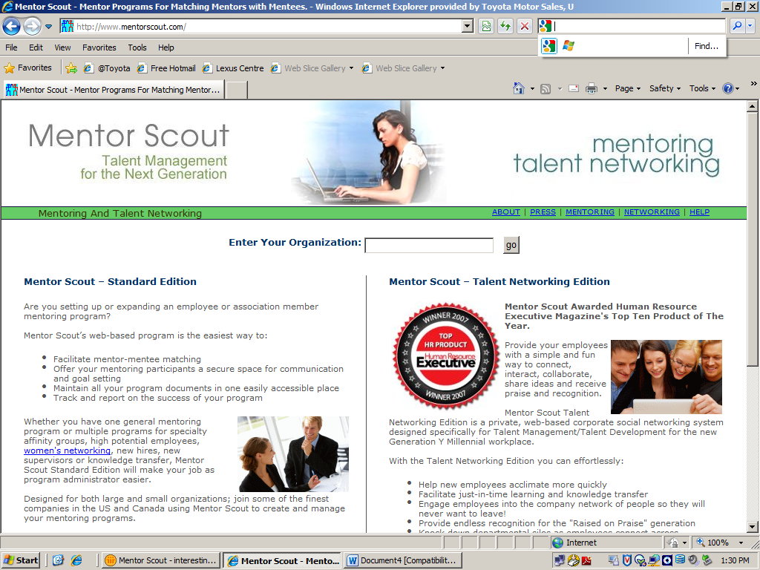

- Links and information provided on this landing page are created and managed by Nobscot Corp., the company which developed the Mentor Scout software. Information contained on this page may not be relevant for Toyota clients.
- Mentor Scout is designed to be a self-service mentoring tool, meaning that much of the process and functionality is self-explanatory. Key features of the tool will be explained in this document, but not all of them will be covered in detail. This is intentional, as some features are critical to the mentor-matching process and others are provided as optional benefits to users. Feel free to explore (and try) the website and all of its functionality on your own or with your mentoring partner.
Complete Your Personal Profile
- Before you will be able to search for a mentoring partner, you will need to create a personal profile. By creating your personalized mentoring profile, you are providing important background information to potential mentors or mentees which is useful for the matching process and during the mentoring relationship.

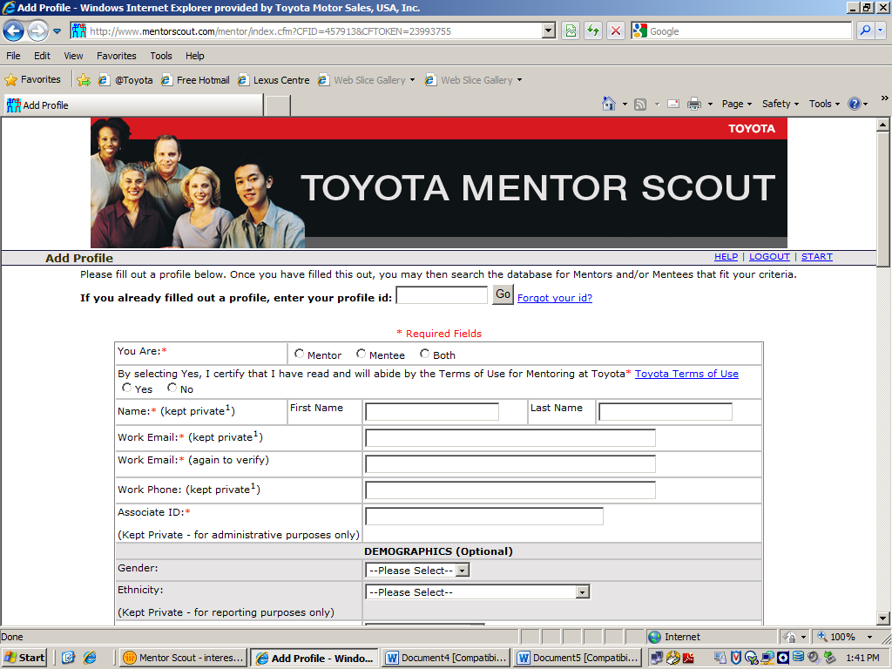

- Complete the fields of the profile as thoroughly as possible. Fields marked with a red asterisk are required. When finished, click “Submit Profile” at the bottom of the page.
- “Kept Private” fields (such as Name, Email, and Phone) are hidden from all users until a mentorship is agreed upon by both parties. This is done to help focus the search process on key skill areas rather than on name or job title. At the time a new mentorship is established, name and contact information is shared between mentor and mentee.
- Tips on Completing the Profile Fields:
  - The fields included in the personal profile cover such things as background, work experience, and skill areas. Profile fields were created to be straightforward and easy to complete, though new users may need a bit more information about two: “Skill Areas” and “Development Areas.”
    - “Skill Areas” are those areas in which you demonstrate strength. Keep in mind that users will frequently use this field as a search criteria when seeking to establish a mentoring relationship. For example, a mentee may choose to search for a mentor with a “Skill Area” of “Innovation.”
    - “Development Areas” are those areas in which you would like to improve. This field, like many others, is optional, though it is particularly important for those associates seeking a mentor. The development areas identified here can provide a valuable starting point for conversations between mentor and mentee. Also, listing development areas in your profile can help a potential mentor determine if s/he has the right strengths to help you meet your development goals before establishing a mentorship.

- Within a few minutes of submitting your profile, you will receive an email to Lotus Notes with your profile id. This is a personalized code which give you access to the rest of the Mentor Scout website.
Learn About the Features of Toyota’s Mentor Scout Website
- Use the profile id emailed to you to access the rest of the Mentor Scout website, and (once the initial two-week waiting period is over) to begin your search for a mentoring partner.
  - Remember: In order to match you with the best possible partner, it is important to allow time for other users to complete an online profile before conducting a mentor or mentee search.
- On the Start page, you will see a menu of options available to you:
  - Quick Search
  - Advanced Search
  - Manage my Mentorships
  - My Profile / Edit Profile
  - Mentoring Documents
  - Change Profile Id

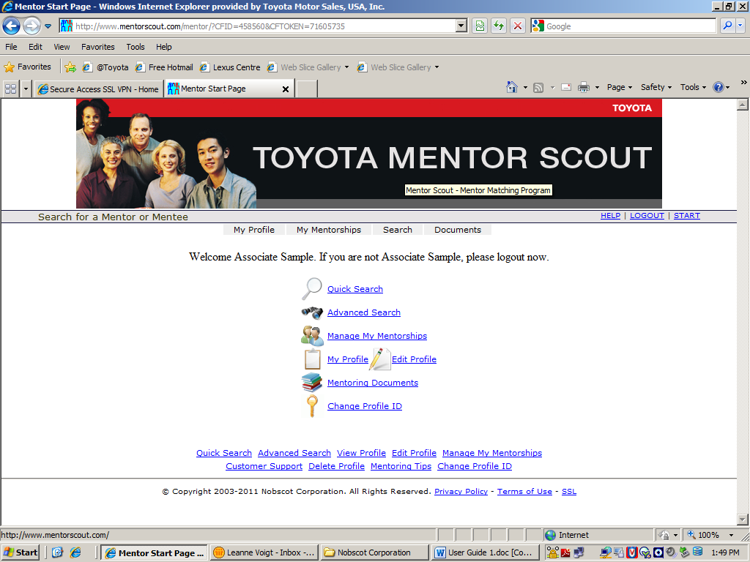

- Quick Search: The “Quick Search” link will take you immediately to a search screen where you will be able to search for a Mentor or Mentee with talent in one or more Skill Areas you select. Simply select one or more Skill Areas then click the “Find your Mentor or Mentee” button to see a list of other Mentor Scout users who have a profile which matches your search criteria.
- Advanced Search: Use the “Advanced Search” link to search for a mentor or mentee using criteria other than simply Skill Areas. You can use as many search criteria as you would like. Keep in mind, however, that the more specific your search, the more difficult time you will have finding a mentorship partner who meets your criteria.
  - Another way to search for a mentoring partner is to use a “Keyword Search”. Click the “Search” tab at the top of the screen to see the “Keyword Search” link. A keyword search allows you to check for a specific word or label that another user may have typed into one of the profile fields. For example, you may want to do a “Keyword Search” for a partner with experience in “Airflite” or membership in “Toastmasters.”
- Manage My Mentorships: Click “Manage My Mentorships” to see, at a glance, all of your current established and pending mentoring relationships. You can use this page to view the profiles of your mentoring partners, keep notes about your meetings, and/or as a place to track your mentoring goals. This is also where you will find the option to “End Mentorship.”
- My Profile/Edit Profile: Use this link to view and/or edit your personal profile. (See the next section of this guide for additional notes on the profile screen.)
- Mentoring Documents: A number of helpful reference documents are available to you in Mentor Scout. You will find them by clicking on the “Mentoring Documents” link.
  - Note: These documents are included as optional resources for those who find them valuable. If you feel they will assist you in your mentoring relationship, please use them as needed.
- Change Profile ID: We recommend that you use the “Change Profile ID” link to update your profile id to one that you will easily remember. You will need to use it every time you access Mentor Scout.
Search for a Partner and Establish a Mentorship
- Search for a mentor or mentee using the “Quick Search,” “Advanced Search,” or “Keyword Search” links.
  - Quick Search: The “Quick Search” link will take you immediately to a search screen where you will be able to search for a Mentor or Mentee with talent in one or more Skill Areas you select. Simply select one or more Skill Areas then click the “Find your Mentor or Mentee” button to see a list of other Mentor Scout users who have a profile which matches your search criteria.
- Advanced Search: Use the “Advanced Search” link to search for a mentor or mentee using criteria other than simply Skill Areas. You can use as many search criteria as you would like. Keep in mind, however, that the more specific your search, the more difficult time you will have finding a mentorship partner who meets your criteria.
  - Another way to search for a mentoring partner is to use a “Keyword Search”. Click the “Search” tab at the top of the screen to see the “Keyword Search” link. A keyword search allows you to check for a specific word or label that another user may have typed into one of the profile fields. For example, you may want to do a “Keyword Search” for a partner with experience in “Airflite” or membership in “Toastmasters.”
- Tips to Improve Your Searches: Some tips to keep in mind when searching for a mentor (or mentee):
  - Think about the skill areas you most need or want to develop. Try to focus on one or two high priority areas at first.
  - The more criteria you include for your search, the better your mentorship match will be. However, including too many search criteria (particularly for the pilot) may limit the results of your search.
    - Remember: The pilot population is limited and may not include partners with all the exact skill areas you are looking for. Be prepared to adjust your search request accordingly.
  - If you have trouble finding a partner who meets your search criteria, try eliminating one or more criteria and re-submitting the search.
- When you request a mentor or mentee through Mentor Scout, an email is sent to this person with a link to your profile. Your name, email address and job title are kept private. After reviewing your profile, the person you selected will choose to accept or decline your invitation to work together.
  - Remember: Names and contact information remain private until a mentorship is agreed on.
  - The mentor/mentee matching process is based on mutual selection. That is, both parties have the opportunity to review a potential partner’s profile before agreeing to a mentorship.
  - If you request a mentorship that is ultimately declined, keep in mind:
    - It is not personal. The partner you requested does not know your name/identity.
    - Mentors are asked in the profile to identify the maximum number of mentees they can work with. If your partnership request is declined, it is possible that the person you contacted has reached his or her maximum number of mentees.
- A sample email is provided for your use when requesting a mentoring partner. You have the option of adding your own text to the email by typing it into the “Add Comment/Personalize:” text box.
Get Your Mentorship Going
- Some of you may already have experience with mentoring and feel that you are ready to begin right away. Go for it, and remember we’re here if you need us. Others of you may be new to mentoring relationships or may feel stuck about how to begin. Either way, here are a few ideas to get you started right away.
  - Once your mentorship is established, you will be notified by Mentor Scout that a series of questions has been added to your profile. The questions address such things as your views on mentoring relationships and your preferences for working together, and are visible only to partners. When you are notified to do so, you should log into the Mentor Scout site to view and respond to the questions. The answers to these questions can provide a useful starting point for conversations with your mentoring partner.
  - Now that you’ve been matched with a partner, feel free to get in touch with your mentor or mentee and establish a process that works for both of you. Determine a date and time to have a first meeting, whether it is in person or over the telephone. Agree ahead of time on how you will prepare for your first meeting.
    - Ideas may include drafting a few goals for the mentorship, reviewing your partner’s profile in more detail, completing the additional questions in your profile, reading the responses your partner has written to the additional questions in his or her profile.
  - Take some time to review some of the documents provided for you in the “Mentoring Documents” section of the website. The resources provided here include descriptions of the mentor and mentee roles, mentoring “dos and don’ts”, and more details on starting your mentoring relationship off on the right track. Feel free to use the reference documents in the way that works best for you and your mentoring partner.
- Remember, the Mentor Scout website is a useful place to keep track of your mentoring goals and meeting notes.
    - Click on the “Manage My Mentorships” on the Home page, or click the “My Mentorships” tab at the top of the screen to see a summary of your active and pending mentoring relationships. In the table in the middle of the screen, you’ll see and links to record your “Notes” and “Goals” for each mentorship, as well as a link to use when you are ready to “End (your) Mentorship.”

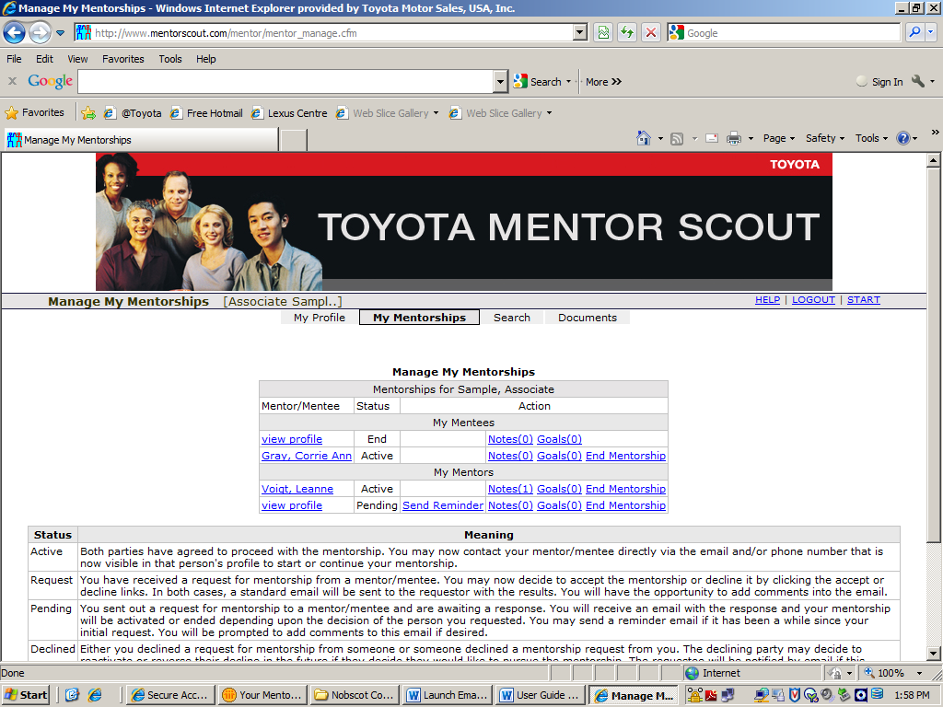

Become Familiar with Other Mentor Scout Features
- There are many other features of the Mentor Scout website that are not fully covered in this User Guide. Please explore and experiment with the features that work for you and your partner.
- As you get to know the Mentor Scout website, here are just a final notes to keep in mind:
  - You can view or edit your mentoring profile at any time by logging into Mentor Scout and clicking the “My Profile” link.
  - Special Profile Tabs: When you view your completed mentoring profile, you will see the following special tabs at the top of the screen:
    - Projects: Use this tab as a place to share the current projects you are working on and projects you are interested in working on.
    - Resources: This tab allows you to share any favorite websites, magazines, books, podcasts, etc.
    - Scrapbook: The scrapbook tab is an open-ended field that you can use to share any additional information about yourself that you think might be useful to your mentor or mentee. This might include personal experiences, your past mentoring experiences, links to web-based photographs, or anything else you feel might be valuable.
  - Information you provide in the above profile tabs will be visible to your mentoring partners, as well as those considering a partnership with you. While use of these tabs is optional, it may be a valuable resource for your mentoring partner as you work toward your goals and/or to others considering a mentorship with you.
  - Notes, Goals: Within the “Manage My Mentorships” page, you will see links to Notes and Goals in the Actions column. This is simply a place where mentors and mentees can record the goals that have been established for their various mentorships and notes related to meetings or action steps. These pages can be used multiple ways to meet your needs, or you can choose to use some other method to record goals and meeting notes.
  - Additional Profile Questions: Once your mentoring relationship is established, you will be notified by Mentor Scout that additional fields have been added to your profile. These fields are a series of additional questions that will help start off your mentoring relationship on the right foot, and include such things as your views on the mentor/mentee roles, communication preferences, and confidentiality. These questions can be printed and used as an outline for your first meeting.

